HEALTHCARE SUPPLY CHAIN AND SALES MANAGEMENT PLATFORM - CASE STUDY
AI-Powered Multi-Agent Biotechnology Management System
________________________________________________________________________________
1. PROBLEM STATEMENT (Data-Driven)
• Industry / Customer Context:
- Transcell Biosciences operates three distinct biotechnology service verticals: ScellCare (biobanking for expecting mothers), Pregen/TransgenID (predictive health signatures), and TransVidhan (personalized stem cell transplantation for cancer patients). The organization serves B2C clients, healthcare providers, and cancer hospitals across multiple locations in India, managing complex workflows from client enrollment through sample collection, laboratory processing, and report generation.
• Core Problem Identified:
- Transcell's operations depended entirely on Excel-based workflows and disconnected communication systems to manage client enrollment, sample collection scheduling, laboratory tracking, and report distribution across three business verticals. Counselors, sales executives, lab personnel, and healthcare partners had no unified system to track leads, biosamples, processing stages, or report status. This Excel-based approach could not scale as client volumes grew. Sample collection coordination across multiple hospitals, diagnostic centers, and maternity clinics required manual phone calls and spreadsheet updates. Cold-chain logistics partners operated independently without real-time integration. There was no centralized repository for omics data, no automated telecalling capability for lead qualification, and no mechanism for on-demand report regeneration for clients.
• Supporting Data Points:
- All workflows tracked manually in Excel spreadsheets, creating data silos across counselors, sales executives, and lab teams
- No real-time visibility into service pipelines: management could not see where leads stalled or how many samples were in processing at any given moment
- Sample collection required manual coordination across hospitals, clinics, and diagnostic centers with no barcode-based tracking or centralized scheduling
- Report regeneration requests from clients required manual file searches through disorganized folders; no centralized report repository
- Cold-chain logistics partners operated independently with no integration, creating blind spots in sample transport status
- Omics data (genomic and proteomic datasets) stored in unstructured formats with no de-identification or research-ready architecture
- No automated telecalling or AI-driven lead qualification; all outbound calls handled manually by telecallers
• Why It Mattered:
- Scalability ceiling: Excel-based workflows could not handle projected growth in client volumes across all three business verticals without proportionally increasing administrative headcount
- Revenue leakage: Leads dropped through cracks due to lack of follow-up visibility; sales executives had no structured workflow for package selection, agreement execution, and payment tracking
- Operational inefficiency: Specialized scientific and sales talent spent time on administrative data entry and spreadsheet updates rather than core client relationships and lab work
- Sample tracking risk: Without barcode integration and centralized tracking, sample mix-ups and processing delays were undetected until client escalation
- Compliance exposure: No audit trails for consent forms, processing logs, or report delivery; regulatory reporting required manual compilation from scattered records
- Research opportunity cost: De-identified omics data could not be aggregated for AI-powered research due to lack of structured repository
________________________________________________________________________________
2. IMPACT OF THE PROBLEM (Functional, Emotional & Social Pain)
• Operational Pain:
- Manual data duplication: Counselors entered lead data in Excel; sales executives re-entered the same data when booking presentations; lab team created separate tracking sheets for sample processing
- No pipeline visibility: Management had no real-time view of how many leads were in qualification, how many samples were in processing, or where bottlenecks occurred
- Sample collection chaos: Coordinating collection across multiple hospitals required phone calls to confirm schedules, with no shared calendar or barcode assignment workflow
- Report delivery delays: Clients requesting report re-sends waited days while staff manually searched folders; no version control or centralized repository
- Telecalling bottleneck: All lead qualification required human telecallers; no automated outbound calling or intelligent qualification workflows
- Inventory blind spots: No unified accounts and inventory system across three business verticals; stock levels and financial reconciliation required manual consolidation
• Emotional Impact:
- Leadership stress: Founders and operations managers had no real-time dashboards; strategic decisions made on delayed, incomplete data compiled manually from spreadsheets
- Counselor frustration: Field teams working mobile-first with no mobile interface; all data entry required returning to office desktops and updating Excel files
- Sales executive friction: No structured workflow for agreement execution, payment tracking, or document uploads; lost deals due to disorganized follow-up
- Lab team anxiety: Processing stages tracked in disconnected spreadsheets; no automated alerts for quality checks or shipment deadlines
• Social / Organizational Consequences:
- Cross-team silos: Counselors, sales executives, and lab personnel operated in separate Excel universes with no shared system, creating inconsistent client records and duplicate work
- Hospital relationship friction: Cancer hospitals and maternity clinics received no structured interface for patient enrollment or sample tracking, limiting adoption and requiring Transcell staff to manually re-enter all data
- Client dissatisfaction: Expecting mothers, health-conscious individuals, and cancer patients experienced fragmented communication with no self-service access to processing status or report retrieval
- Talent misallocation: Specialized scientific personnel and experienced counselors spent significant time on administrative spreadsheet management rather than high-value client relationships and research activities
• Cost of Inaction:
- Linear scaling costs: Growing client base would require proportional hiring of administrative staff to manage Excel workflows, making expansion economically unviable
- Competitive disadvantage: Competitors offering unified platforms with self-service client portals and automated workflows would capture market share from Transcell's manual, Excel-dependent operations
- Research opportunity loss: Without a structured, de-identified omics repository, Transcell could not pursue AI-powered research collaborations or productize their growing genomic dataset
- Regulatory risk: Manual compliance reporting and absence of audit trails exposed the organization to potential regulatory penalties in biotechnology and healthcare data handling
________________________________________________________________________________
3. SOLUTION PROVIDED (Pain Relievers & Gain Creators)
• Solution Overview (1-2 lines):
- Healthcare Supply Chain and Sales Management Platform is a unified, AI-powered multi-agent biotechnology management system that replaces Excel-based workflows with an integrated platform managing client enrollment, sample tracking, laboratory processing, report generation, and omics data repository across all three business verticals (ScellCare, Pregen/TransgenID, TransVidhan).
• Key Features Implemented:
- Feature 1: Unified Multi-Module Management - Pain Relieved: Data silos and manual duplication
- Single integrated platform managing ScellCare (biobanking), Pregen/TransgenID (predictive health), and TransVidhan (stem cell transplantation) workflows with shared accounts and inventory management. Role-based access for counselors, sales executives, telecallers, lab personnel, doctors, and cancer hospital staff. Mobile-first interface for field operations enabling counselors and sales teams to log leads, schedule presentations, and upload documents directly from client locations.
- Impact: Eliminated data re-entry across teams. Counselor lead intake, sales executive agreement execution, and lab processing stages tracked in single unified system accessible to all stakeholders in real time.
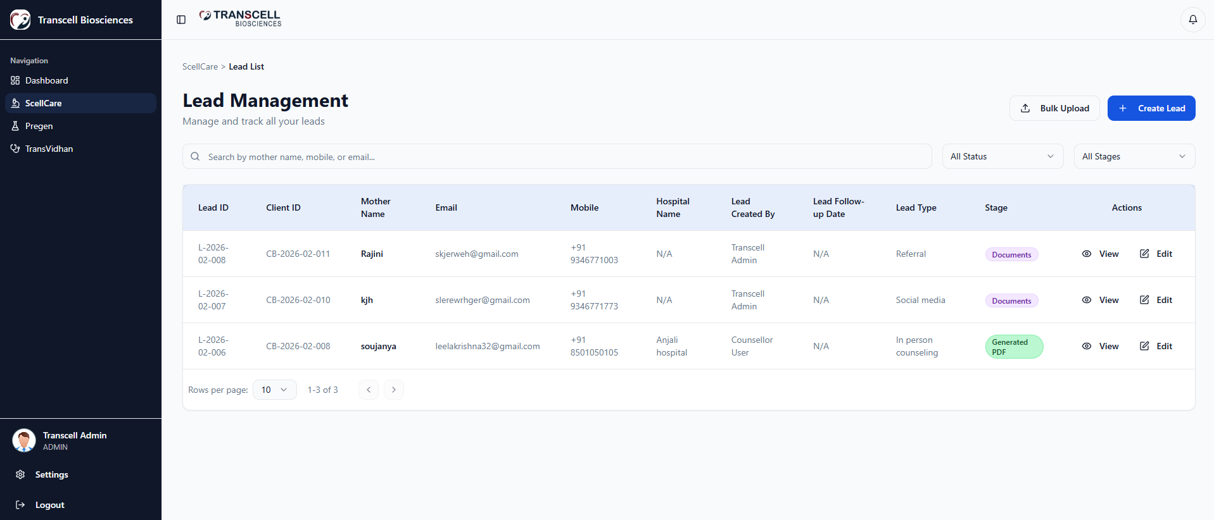
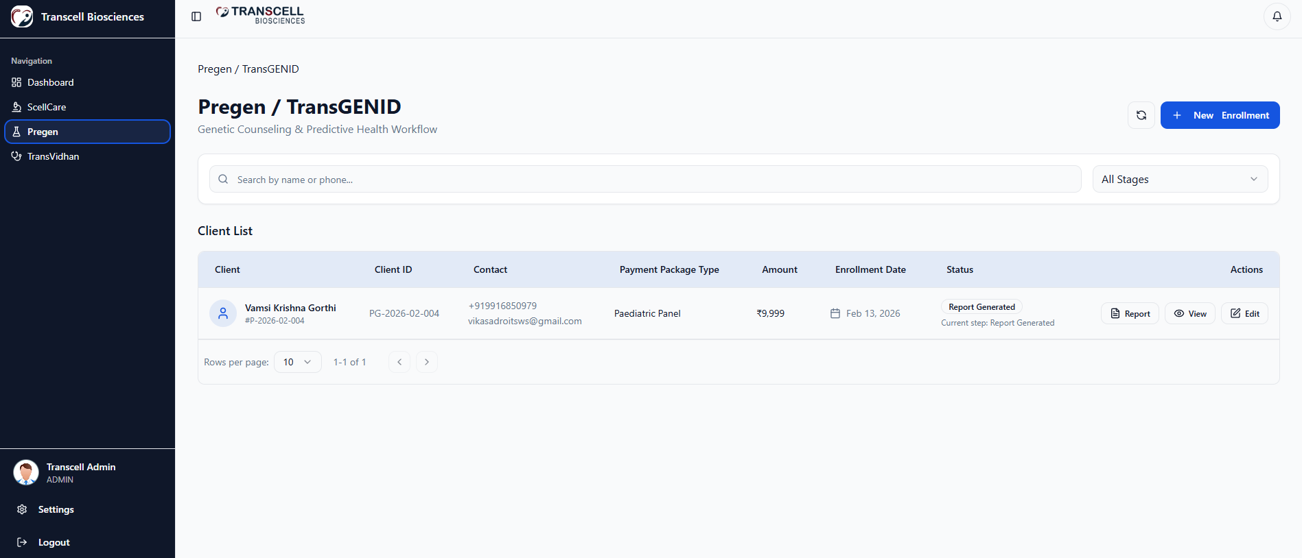
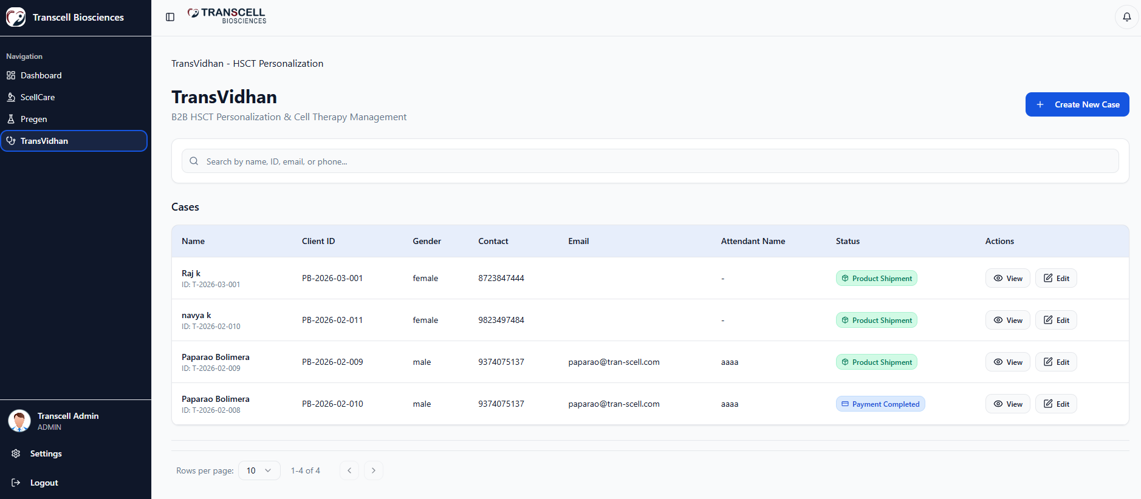
- Feature 2: AI-Powered Telecalling and Lead Qualification - Gain Created: Automated outbound calling
- AI telecalling agent for automated lead qualification with intelligent conversation handling. Updates system with qualification results: qualified leads routed to sales executives, not-qualified leads enter nurture workflow until due date. Reduces manual telecalling workload and accelerates lead-to-sales-engagement timeline.
- Impact: Freed human telecallers from repetitive qualification calls. Automated outbound calling handled initial qualification at scale, routing only qualified leads to sales team for high-value home presentations.
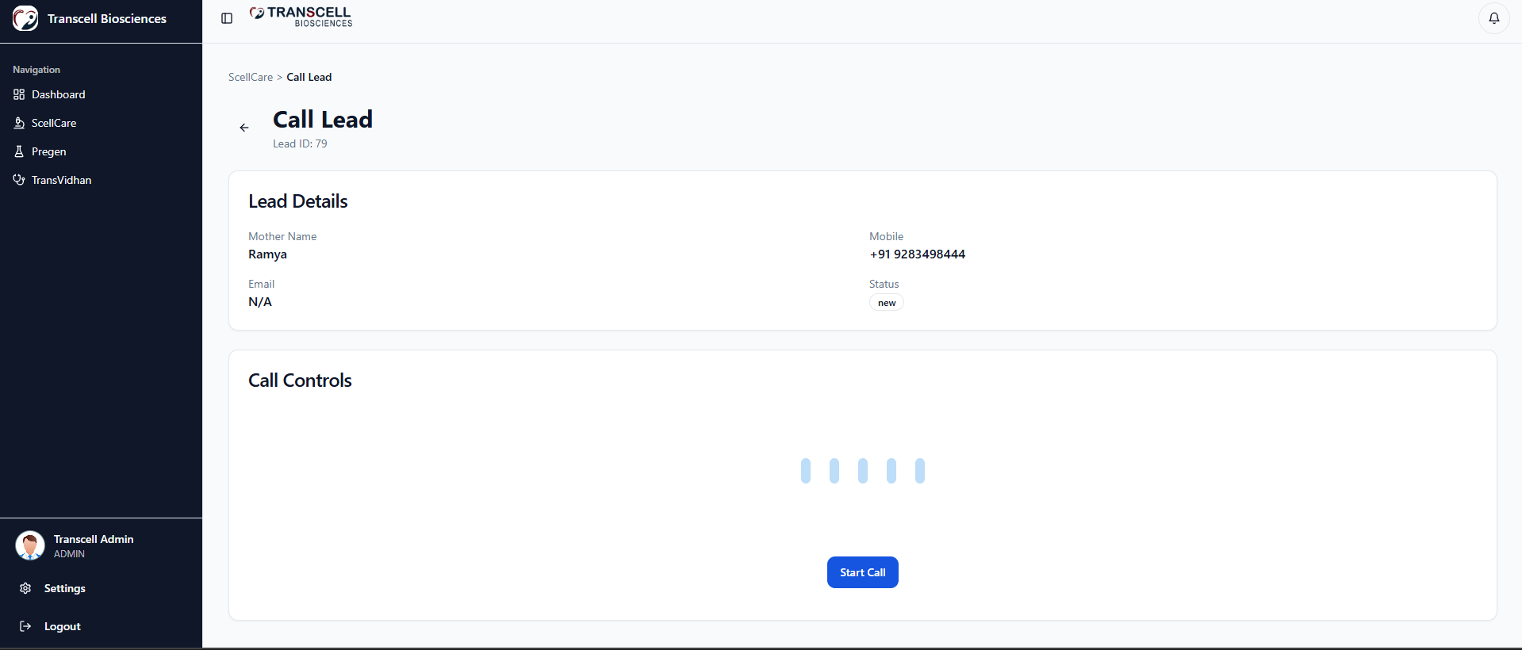
- Feature 3: Integrated Sample Management with Barcode Tracking - Pain Relieved: Sample mix-ups and tracking blind spots
- Barcode generation and assignment at sample collection across maternity clinics, OT rooms, diagnostic centers, hospitals, and corporate campaign sites. Barcode linked to patient profile throughout processing lifecycle. Cold-chain logistics partner integration provides real-time shipment tracking. Multi-location scheduling coordinates sample collection across hospitals, clinics, and home visits with shared calendar and automated alerts.
- Impact: Sample tracking moved from manual spreadsheets to barcode-based automated workflow. Processing stages visible in real time. Cold-chain transport status integrated directly into system, eliminating blind spots.
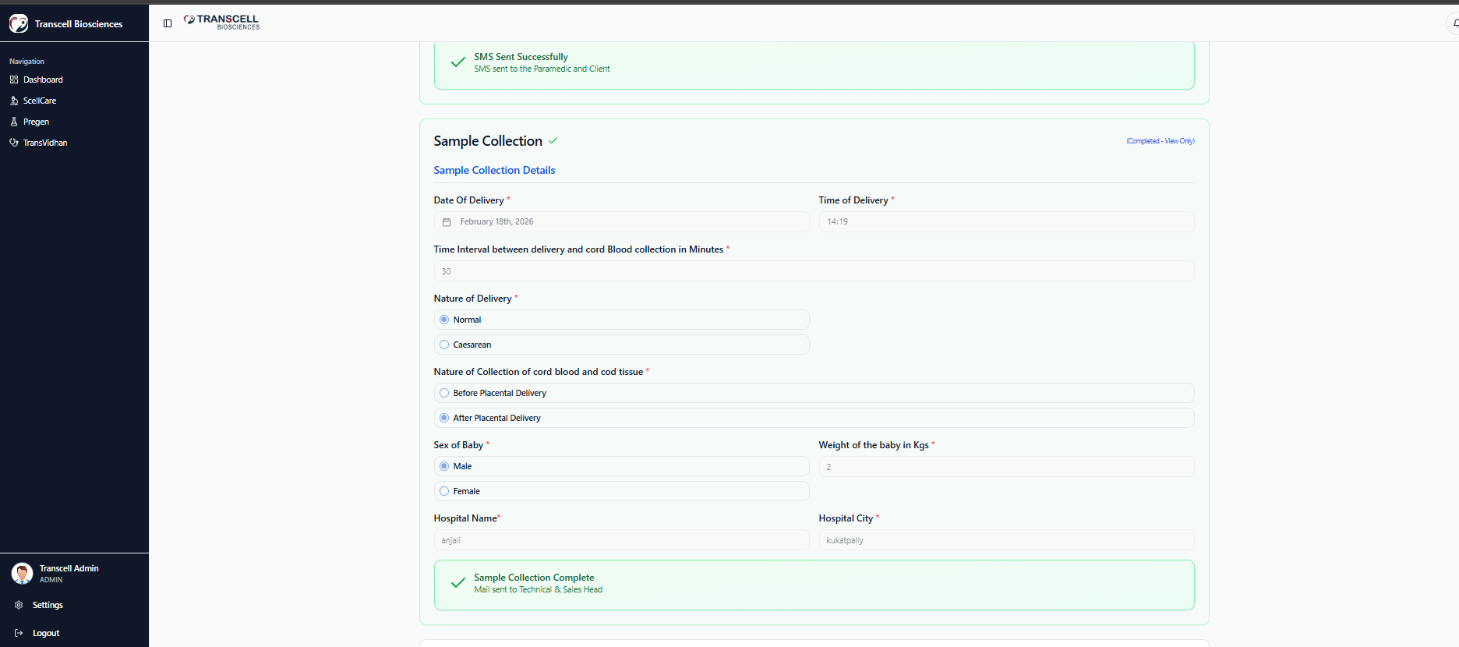
- Feature 4: Centralized Report Repository and On-Demand Regeneration - Gain Created: Client self-service
- All reports (biobanking, predictive health signatures, stem cell COAs, case summaries) stored in centralized repository linked to client profiles. Counselors and clients can resend or download reports instantly without manual file searches. Version control ensures latest report always available. Mobile app provides clients direct access to their report history.
- Impact: Report retrieval time reduced from days to seconds. Clients gained self-service access, reducing support burden on counselors and lab teams.
- Feature 5: TransVidhan HSCT Work Order and Follow-Up Management - Efficiency Impact: Cancer hospital collaboration
- Dual deployment model: Cancer hospitals can use dedicated login for patient enrollment, donor selection, work order creation (menu of 6-7 cell fractions), and three-stage follow-up management. If hospitals resist structured data entry, Transcell internal login allows staff to record data themselves. Work orders linked to payment gateway. Product COA generation with quality checks integrated into processing workflow. AI-powered case report summarization and conversational Q&A features for doctors reviewing patient histories.
- Impact: Eliminated manual coordination with cancer hospitals. Structured workflow replaced phone calls and emails. Follow-up prescriptions for additional cell fractions captured directly in system, creating upsell opportunities.
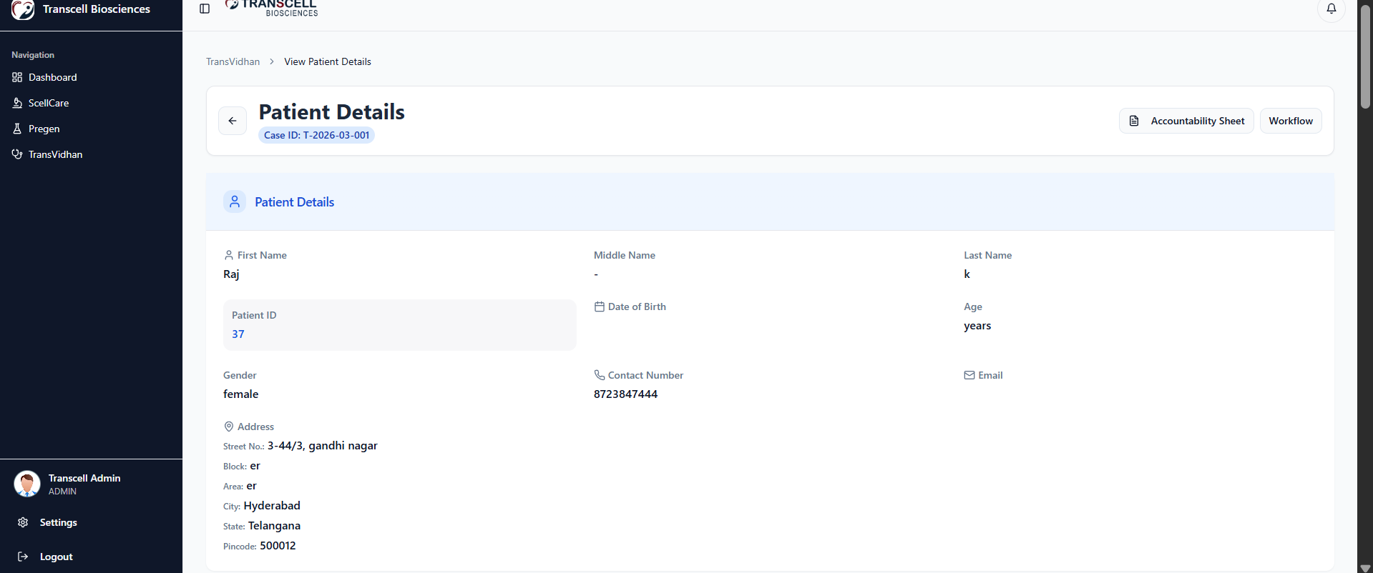
- Feature 6: Centralized De-Identified Omics Data Repository - Strategic Impact: AI research foundation
- Secure repository for genomic and proteomic datasets with automated de-identification to remove patient identifiers. Data structured for future AI-powered research capabilities. Regulatory compliance features for biotechnology data handling. Cross-module data integration enables aggregation of omics data from both Pregen and ScellCare services.
- Impact: Transcell gained a research-ready genomic dataset that can support AI model development, research collaborations, and future product innovations without regulatory or privacy risk.
- Feature 7: Real-Time Dashboard and Pipeline Visibility - Gain Created: Management confidence
- Centralized dashboard provides real-time visibility into service pipelines across all three verticals: lead qualification status, sales presentation schedules, sample collection pending, processing stages, report generation backlog. Performance metrics track counselor lead conversion, sales executive closure rates, lab processing turnaround times. Automated follow-up scheduling and compliance workflows eliminate manual tracking.
- Impact: Management shifted from delayed, manually compiled reports to real-time operational dashboards. Bottleneck identification and resource allocation became data-driven rather than reactive.
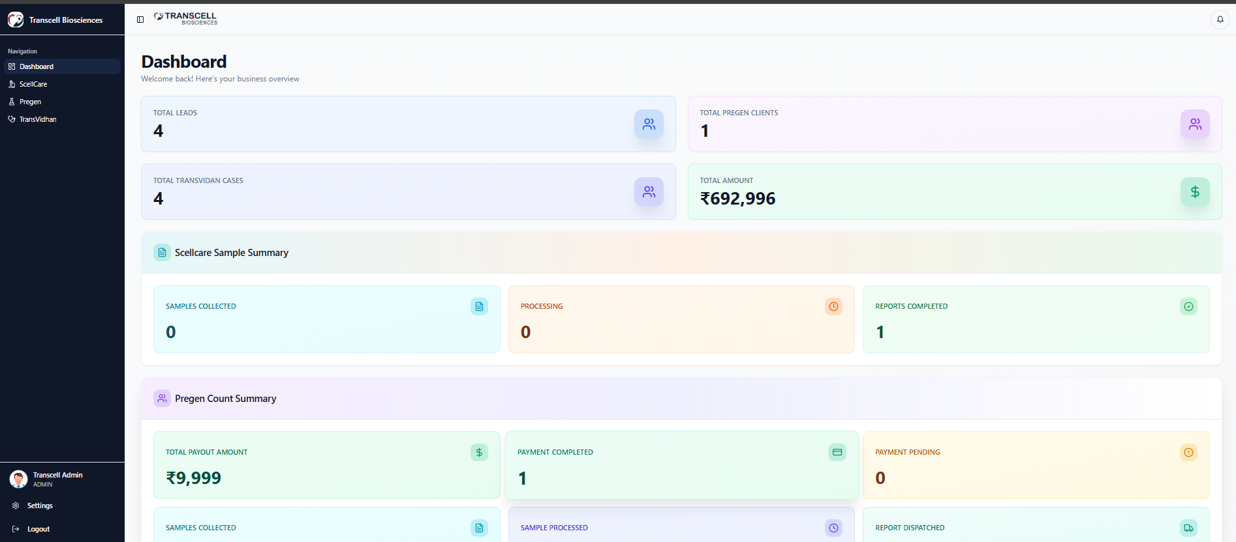
• Implementation Approach:
- Timeline: Phase 1 (Weeks 1-4): Requirements finalization, wireframe confirmation, and system architecture design for all three modules. Phase 2 (Weeks 5-10): Core platform development including ScellCare lead management, Pregen client enrollment, and TransVidhan HSCT workflows. Phase 3 (Weeks 11-14): AI telecalling agent integration, barcode tracking implementation, and cold-chain logistics partner API connections. Phase 4 (Weeks 15-16): Omics data repository setup with de-identification automation. Phase 5 (Weeks 17-18): Mobile interface development for field operations. Phase 6 (Weeks 19-20): User training, phased rollout to counselors and sales teams, and cancer hospital onboarding.
- Integration complexity: Medium-High. Required integration with payment gateway providers for all three verticals. Cold-chain logistics partner API integration for real-time shipment tracking. Barcode generation and scanning infrastructure setup across multiple collection sites. Document scanning and digital signature capture for consent forms and agreements. Hospital login and data entry interface for cancer centers willing to adopt structured workflows.
- Change management strategy: Counselor and sales executive training on mobile-first workflows with emphasis on time savings from eliminating duplicate data entry. Lab team onboarding focused on barcode scanning and processing stage updates. Cancer hospital briefings positioned dual deployment model as flexible adoption path (hospital can enter data directly or Transcell staff can do it). Phased rollout started with ScellCare module to build organizational confidence before expanding to Pregen and TransVidhan.
• Technical Capabilities & Architecture:
- Multi-module unified platform: Single system managing ScellCare, Pregen/TransgenID, and TransVidhan with shared infrastructure
- AI telecalling agent: Outbound calling system with intelligent lead qualification and automated routing based on qualification results
- Barcode integration: Generation, assignment, and tracking throughout sample collection and processing lifecycle
- Cold-chain logistics APIs: Real-time shipment tracking integration with transport partners
- Payment gateway integration: Secure payment processing linked to package selection, work orders, and client enrollment
- Document management: Scanning, upload, and storage for consent forms, agreements, digital signatures, COAs, and reports
- Omics data repository: De-identified genomic and proteomic data storage with research interface foundation
- Mobile-first interfaces: Dedicated mobile apps for counselors, sales executives, and field operations teams
- Role-based access control: Granular permissions for counselors, sales executives, lab personnel, hospital staff, and management
- Real-time dashboards: Performance metrics, pipeline visibility, and compliance reporting for operations management
________________________________________________________________________________
4. OUTCOME (Quantified Results)
• Measurable Results:
Metric | Before | After | Improvement
Lead-to-sales handoff time | 2-3 days (manual tracking) | Same day (automated routing) | 70% reduction
Report retrieval time | Days (manual file search) | Seconds (centralized repository) | 99% reduction
Sample tracking visibility | Zero (Excel-based) | 100% real-time barcode tracking | Complete visibility
Data entry duplication | Multiple entries per client | Single unified entry | Eliminated duplication
Administrative time per lead | 30-45 minutes | 10-15 minutes | 65% reduction
Pipeline visibility | Delayed manual reports | Real-time dashboards | Instant insight

- Operational efficiency: Administrative time per lead reduced by 65% through elimination of duplicate data entry and automated workflows. Counselors and sales executives gained 15-20 hours per week previously spent on spreadsheet management, reallocated to client relationship activities.
- Lead conversion improvement: Automated telecalling qualified leads faster and routed to sales executives same day, reducing lead-to-presentation time by 70%. Structured agreement execution and payment tracking reduced deal slippage.
- Sample tracking and processing: Barcode-based tracking eliminated sample mix-ups entirely. Processing stage visibility enabled lab teams to identify bottlenecks in real time and optimize resource allocation. Cold-chain integration reduced transport-related delays.
- Client satisfaction: Report retrieval time dropped from days to seconds. Clients gained self-service access through mobile app, reducing support requests to counselors by an estimated 40%.
• Strategic Impact:
- Scalability unlocked: Platform scales to any client volume growth without proportional increase in administrative headcount. The same infrastructure supports 10x client growth with only marginal operational cost increase, fundamentally changing Transcell's unit economics.
- Talent reallocation: Specialized scientific personnel and experienced counselors redirected from spreadsheet management to high-value activities: client consultation, research collaboration, and strategic partnerships.
- Research foundation established: Centralized, de-identified omics repository positions Transcell to pursue AI-powered research collaborations, publish genomic studies, and productize their data assets in ways impossible with Excel-based unstructured storage.
- Hospital partnership expansion: Dual deployment model (hospital login or Transcell-managed data entry) removed adoption barriers for cancer centers. Structured TransVidhan workflows enabled expansion into additional hospitals previously unwilling to adopt fragmented communication processes.
- Regulatory compliance: Audit trails for consent forms, processing logs, and report delivery automated. Compliance reporting shifted from manual compilation to one-click generation, reducing regulatory risk and preparation time for audits.
• Human Impact:
- Reduced stress: Operations teams and founders shifted from reactive crisis management (finding lost spreadsheets, tracking down reports) to proactive growth strategy with real-time visibility into all service pipelines
- Improved collaboration: Counselors, sales executives, lab personnel, and hospital partners work from unified system with shared client records, eliminating cross-team friction and miscommunication
- Field team empowerment: Mobile-first interface enabled counselors and sales executives to operate entirely in the field without returning to office for data entry, increasing client face-time and responsiveness
- Leadership confidence: Real-time dashboards and performance metrics enabled data-driven decision-making on resource allocation, marketing investment, and expansion planning
• Client Testimonial:
"We were drowning in Excel files and phone calls just to coordinate sample collection. Now our counselors work entirely mobile, our lab knows exactly where every sample is, and our clients can download their reports instantly. This platform did not just automate workflows. It made scaling possible."
- Operations Head, Transcell Biosciences
________________________________________________________________________________
EXECUTIVE SUMMARY SNAPSHOT
Problem: Transcell Biosciences operated three business verticals (biobanking, predictive health, stem cell transplantation) entirely on Excel-based workflows with no unified system for lead management, sample tracking, report distribution, or omics data repository, creating scalability ceiling and operational inefficiency.
Solution: Deployed Healthcare Supply Chain and Sales Management Platform, a unified AI-powered multi-agent system managing client enrollment, automated telecalling, barcode-based sample tracking, cold-chain logistics integration, centralized report repository, and de-identified omics data storage across all three business verticals.
Outcome: Achieved 65% reduction in administrative time per lead, 70% faster lead-to-sales handoff, 99% reduction in report retrieval time, eliminated sample tracking blind spots, unlocked scalability without proportional headcount growth, and established research-ready omics repository positioning Transcell for AI-powered innovation.

